Title (Arial 12 pt bold) (the title must be the same as the title of the poster or conference)
Author names (Arial 11pt) N.Lastname1¹ (underlining the name of the author attending the meeting), N. Lastname2¹, N. Lastname3,² ...
¹ Affiliation 1, address1, e-mail
² Affiliation 2, address 2

This area of the template should contain the summary of the contribution with a margin of 2 cm on each side, with a maximum occupancy of 1 page and using Arial 10pt font throughout the text. All paragraphs should be in justified paragraph format. References should be indicated throughout the abstract in the format [1] or [2,3] and should be included at the bottom of the page using Arial 8pt font.

Figures (jpg or other MSWord compatible format) must be inserted in the text.
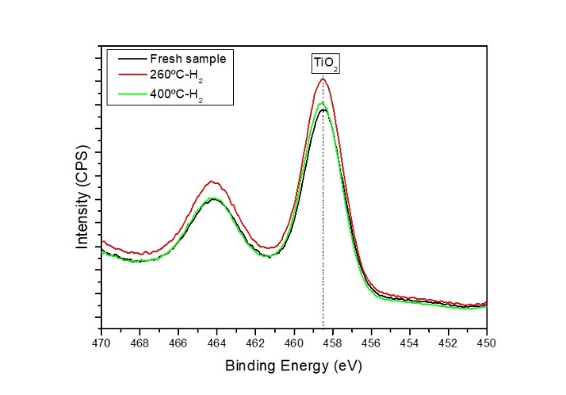
The final file must be saved in this same MSWord format, indicating in the file name the surname of the author attending the meeting and the type of contribution (Oral, Flash Oral or Poster Communication).
Example: LastNameAuthor_poster.doc (or .docx).

The abstract should be sent to 3wmpece@icms.us-csic.es as an attachment or through the webpage.

References
[1] N. Author1, N. Author2, N. Author3, J. Am. Chem. Soc., 2011, 137, XXX-XXX.

